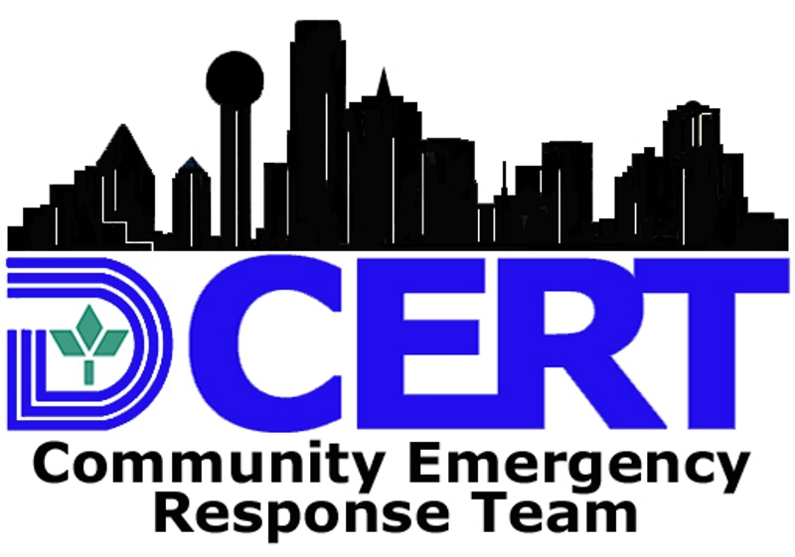

DALLAS COMMUNITY EMERGENCY RESPONSE TEAM

WAIVER AND RELEASE AGREEMENT

The undersigned, being at least eighteen years of age, and in consideration for acceptance, approval and participation in the Dallas Community Emergency Response Team (“CERT”) Program, do hereby agree to this waiver and release.

I fully understand and recognize that the Dallas CERT Program will involve physical labor and may carry a risk of personal injury. I further recognize that there are natural and manmade hazards, environmental conditions, diseases, and other risks, which in combination with my actions can cause injury to me. I hereby agree to assume all risks which may be associated with or may result from my participation in the Dallas CERT Program, including, but not limited to, transportation to and from volunteer sites; extinguishing small fires; providing disaster medical care; performing light search and rescue activities; rehabilitation and relief services; communications; and other similar activities.

To the extent that I have a known heart condition, serious health problems, or a physical impairment or handicap, I state that I will not perform or attempt to perform any acts that could result in physical harm to me or to any other person. I further state that if any representative, officer, employee, instructor, member, volunteer leader, agent, official or staff of the City of Dallas or Dallas Fire Department or sponsor of the Dallas CERT Program recommends, for any reason, that I refrain from participating in any activity, or end my participation in any ongoing activity, associated with the Dallas CERT Program, I will refrain from participating in or withdraw my participation from such activity immediately.

I recognize that if I am accepted for the program, I may be covered by the provisions of the "Charitable Immunity and Liability Act of 1987" (Tex. Civ. Prac. & Rem. Code §§ 84.001-84.008), the Medical Liability Act (Good Samaritan Law) (Tex. Civ. Prac. & Rem. Code §§ 74.151), and the “Volunteer Protection Act of 1997,” 42 U.S.C. §§ 14501-14505, during the time that I am performing approved volunteer activities.

I agree to release, hold harmless and indemnify the City of Dallas and the Dallas Fire Rescue and Police Departments and its officers, employees, instructors, members, volunteers, agents, and all sponsors and/or officials and staff of any said entity or person, their representatives, agents, affiliates, directors, servants, volunteers and employees from any and all liability, claims, demands, actions, and causes of actions whatsoever for any loss, claim, damage, injury, illness, attorney's fees or harm of any kind or nature to me arising out of any and all activities associated with the Dallas CERT Program.

I further agree to indemnify and hold harmless, and hereby release the above mentioned entities and persons from and against any and all claims, losses, damages, causes of action, suits, and liability of every kind, including all expenses of litigation, court costs, and attorney’s fees, brought by any member of my family, estate, heirs, or assigns for injury to any person, or for damage to any property, arising out of or in connection with my participation in the Dallas CERT Program.

In consideration of being allowed to participate in the Dallas CERT Program, I hereby authorize the City of Dallas employees to take my photograph and to use (both while participating and anytime after) my likeness, name, voice, or words in either television, radio, film, newspapers, magazines, and other media, in any form, for the purpose of presenting, advertising or communicating the purposes and activities of the Dallas CERT Program and/or applying for funds to support these purposes and activities.

I UNDERSTAND THAT I WILL NOT RECEIVE COMPENSATION FOR MY SERVICES AS A DALLAS CERT VOLUNTEER. I HEREBY AGREE TO READ THE DALLAS CERT PROGRAM RULES, REGULATIONS, POLICIES, PROCEDURES, AND CODE OF CONDUCT AND TO COMPLY WITH SUCH RULES, REGULATIONS, POLICIES, PROCEDURES, AND CODE OF CONDUCT. I HAVE CAREFULLY READ AND UNDERSTAND THE CONTENTS OF THIS WAIVER AND RELEASE AND I SPECIFICALLY INTEND IT TO COVER MY PARTICIPATION IN THE DALLAS COMMUNITY EMERGENCY RESPONSE TEAM PROGRAM.

____________________________________________ ____________________
Signature Date Signed
____________________________________________
Printed Name

____________________________________________ ________________________
Witness Signature Date Signed
_____________________________________
Witness Printed Name

